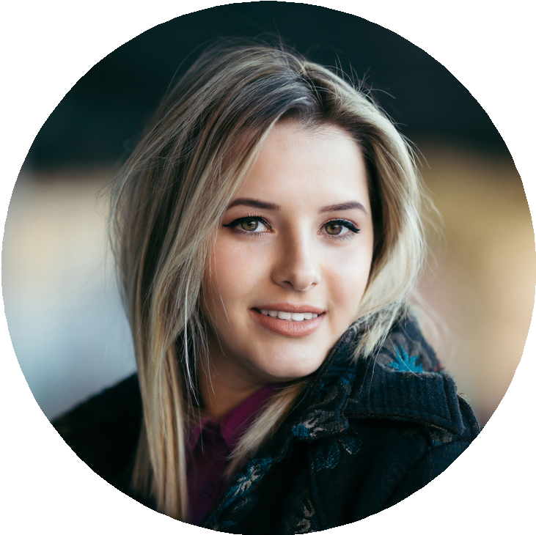

Olivia
Wilson

Experience
About Me
Becoming a barista is my dream come true because I have been a coffee lover since I was in high school. and I always develop my talent in processing coffee
Education
2017 | Esperto Barista Course
Espresso
Esperto Barista Course
2019 | Caswell's Coffee Lab
designing a unique and quality coffee drink menu
Skills
Espresso Ristretto latte art doppio lungo

Barista Junior

Barista - Six Ounces Coffee 2018-2019
Processed drinks and coffee go well with food.
Provide customer feedback to select the right coffee and tea blend for their preferences.

Barista Professional

Barista - Six Ounces Coffee 2019-2020
Processed drinks and coffee go well with food.
The new drink helped increase turnover by 25% from 2018 to 2019.

Barista Leader

Barista - Six Ounces Coffee 2020-2021
Processed drinks and coffee go well with food.
The new drink helped increase turnover by 25% from 2018 to 2019.

Contact

+123-456-7890

hello@reallygreatsite.com

123 Anywhere St., Any City, ST 12345

